# Optimisation

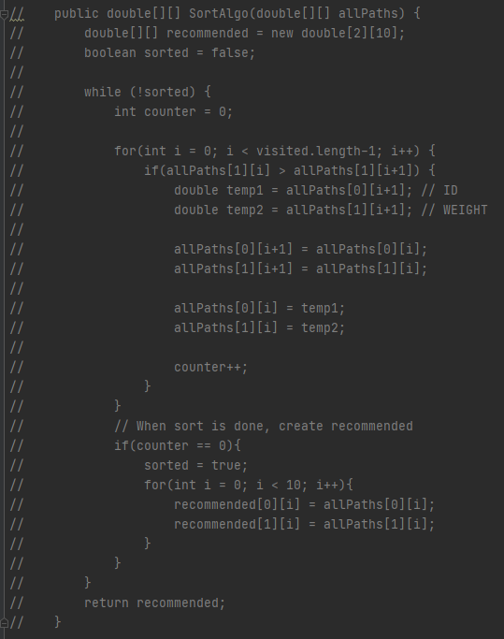

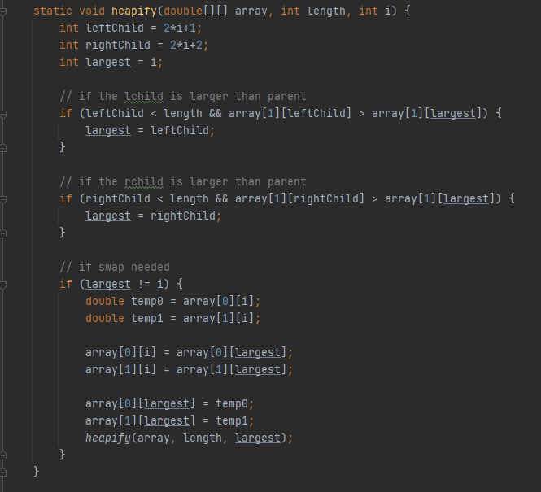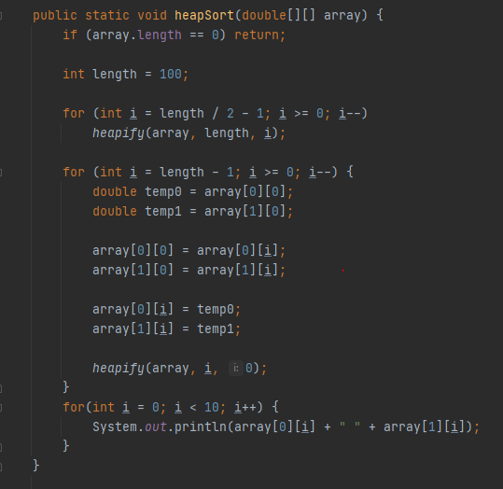Depreciated bubble sort algorithm (above)

New heap sort algorithm (above)

I’ve implemented a heap sort algorithm which should in theory be more efficient than the previous implementation of a bubble sort.